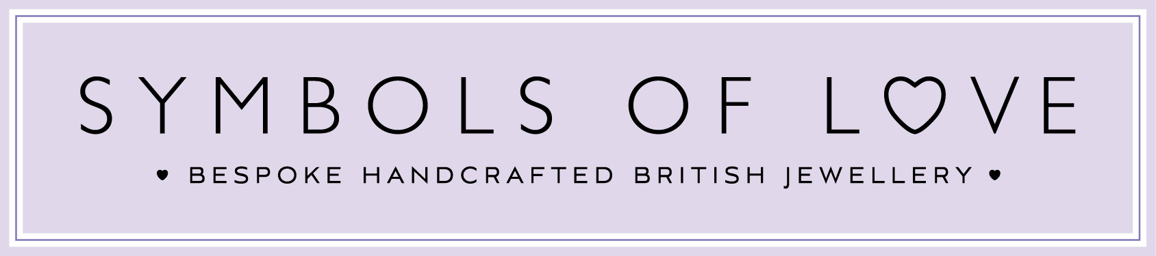

1. Definitions.
In these terms and conditions, the following meanings will apply: The Company means Symbolsoflovejewellery.com of Romford. Customer means the person or company whose details are entered on any order or enquiry form on this website. Browser means any person accessing and using this website by means of software products enabling Internet connection. The Website means the website at www.symbolsoflovejewellery.com and www.symbolsoflove.net
2. Copyright.
The website is owned and operated by The Company and all contents and designs are copyright of The Company and its suppliers or agents. Browsers using the site are permitted limited rights to view and print the contents for personal use only and are prohibited from copying, reproducing, or reusing any of the contents or designs in any medium for any other purpose, in particular but not exclusively for any commercial gain.
3. Products and Services.
Products and services offered by The Company, including for sale through The Website. The company undertakes that all products are of suitable quality for purpose (however, Customers are asked to ensure that gold carat, stone size & quality, design style colour details are carefully checked before ordering as mistakes may not be rectifiable. Precise colour or specification details may vary from illustrations)
4. Price and Payment.
Any prices shown on the website are in pounds sterling & inclusive of VAT, which is applicable on all consumer sales throughout the European Union. The Company reserves the right to vary prices to reflect changes in price of precious metals & currency exchange rate fluctuations from its suppliers without notice and the contract price will be the price quoted in the contract confirmation.
The price of the contract will require to be paid in full prior to dispatch of the products or fulfilment of the services unless otherwise agreed. Payment is of the essence of the contract and the Company will be relieved of any obligation under the contract if payment is not made in accordance with the contract terms
5. Conditions of Contract.
No contract will subsist between you The Customer and The Company for the sale of product(s) or service(s) to you, unless and until The Company accepts and confirms your order in writing or by email. The contract when formed will be deemed to have been concluded in the UK and will be interpreted, construed and enforced in all respects in accordance with the laws of the UK, and will be subject to the jurisdiction of the UK Courts.
In the event that any clause within these terms is deemed at law to be unreasonable or unenforceable such clause will be deleted and such deletion will have no bearing on the validity or interpretation of the remaining clauses.
6. Delivery.
Delivery of products ordered from stock will normally be made within 7 working days within the UK. Carriages to UK addresses are usually included otherwise will be charged at cost. Overseas delivery will be charged at cost as indicated on the order and confirmed to the Customer with the order acknowledgement.
The Company will use its best endeavours to ensure timely delivery of all orders, but time of delivery will not be capable of being made of the essence of the contract, as actual delivery to the Customer will be by independent carrier and outside the direct control of the Company.
7. Payment and Personal Data Security.
To facilitate effective processing of orders the Company offers secure payment facilities online, via the website and can accept payment by several major credit cards or debit cards by this method. To this end, cookies are used by the website server to track order details only and Customers are asked to accept these files from the website server.
Personal details are encrypted during transmission, stored, and used strictly in accordance with the Companies Data Protection Policy and will not be passed to any third party without your explicit permission.
Alternatively, payment may be made in person at the Companies premises or by cheque or bank transfer by arrangement at time of contract.
8. Warranty.
The Company warrants that all products supplied will be of suitable quality and fit for their designed purpose, (and offers a 2-year guarantee that they will be free from manufacturing defect or fault).
Exceptionally however, any discounted or sale products will be sold as is and are specifically excluded from this guarantee.
No guarantee is offered where products are used for purposes other than that for which they were designed. Fair wear & tear is not covered by this guarantee. This warranty is in addition to, and does not affect, your statutory rights.
Please remember: Your guarantee is invalid if you allow a third party to work on the jewellery we have made for you.
Note; Diamonds DO NOT fall out by themselves, if you keep your ring in the box no stone will ever go missing, they have to be compromised during wear to dislodge from the setting. We appreciate most customers take great care of their jewellery but should you suddenly find a diamond or other stone missing it is usually due to some sort of heavy jolt or knock whilst being worn. Please fully insure your jewellery against loss or damage with a reputable company.
In the event of a loss or burglary we would be delighted to provide an estimate for you or your insurance company
9. Cancellation.
Save as required by the UK Consumer Protection (Distance Selling) Regulations 2000 or pursuant to clause 6 above, the contract will be non-cancellable by the Customer, once confirmed by the Company. Ordering mistakes by Customers with regard to (size, colour or specification for example) will not constitute grounds for cancellation. Notwithstanding, acceptance of cancellation by the Company in exceptional circumstances and any refund or part refund will be solely at the discretion of the Company.
10. Returns.
In the unlikely event of products being faulty or of sub-standard quality, please report such problem immediately to the Company by direct email or using the enquiry form on the website. Arrangements for the return of such product will be made on your behalf and the Company will meet the cost of return by RMSD and at the discretion of the company the fault will be rectified or the item replaced. Goods should be returned together with original packaging wherever possible by RMSD.
In the event of cancellation of the contract, the Customer will be responsible for the costs incurred to manufacture the item, only the intrinsic value of the item will be refunded, and if cancelled after delivery all costs of return of the products in an undamaged, unworn state, together with all original packaging. Any item of value must be returned either by hand or by Royal Mail Special Delivery using maximum insurance cover available.
11. Liability.
To the maximum extent permissible in law, the Company excludes all liability for any loss or consequential loss however incurred by the Customer, arising from any action, omission, or failure by the Company in connection with the contract.
In any event, the maximum liability of the Company will be not more than the purchase price of the products or services under the contract, should the contract be cancelled for any reason.
12. Title and Risk.
Title in the goods will pass to the Customer on payment of the full purchase price. The Company however, will carry risk until such time as the products are delivered to the Customer.
13. Force Majeure.
In the event of circumstances outside the Companies control affecting the performance of the contract, the Company will be entitled to notify the Customer and revise or cancel the contract to reflect the changed circumstances and the Customer will accept such changes.
14. Notices.
All communications in connection with the contract will be deemed to have been served if sent by ordinary mail to the Customers postal address or by email to the Customers email address, as notified to the Company by the Customer.
Customers should email any communication to the Company at info@symbolsoflovejewellery.com
Please remember: Your guarantee is invalid if you allow a third party to work on the jewellery we have made for you.

